IEEE STANDARD 1016: Software Design Specification

The Software Design Document is a document to provide documentation which will be used to aid in software development by providing the details for how the software should be built. Within the Software Design Document are narrative and graphical documentation of the software design for the project including use case models, sequence diagrams, class diagram, state diagram and other supporting requirement information.

The Software Design Specification Outline
1. Introduction

1.1 Purpose of this document
The purpose of the Software Design Document is to provide a description of the design of a system fully enough to allow for software development to proceed with an understanding of what is to be built and how it is expected to build. The Software Design Document provides information necessary to provide description of the details for the software and system to be built. This document is to describe the implementation of Cryptool software that was described in the requirement document. The Cryptool software is design to let the people get familiar with the cryptography and use that technique in ciphering/deciphering the data.

1.2 Scope of the development project
This tool is intended for the user to encrypt text based on various encryption and to learn how the encryption and decryption works. This tool can help the user to get a sight of what is encryption and can continue in this field. In the field of cyber security, cryptography is one of the basic techniques in an interactive manner. Using encryption, the user get complete data protection, security across multiple devices, integrity maintained and ensure compliance.

1.3 Definitions, acronyms, and abbreviations
Encryption- It is the conversion of electronic data into another form.
Decryption – Converting back the encrypted data into another form.
Cryptography- Art of converting data into coded form.
Database – collection of all the information monitored by the system.
MySQL- It is an open-source relational database management system (RDBMS).
CSS3- Cascading Style Sheet.
HTML5- Hypertext Markup Language.
Wamp- Window, Apache, MySQL, and PHP an application server platform.
Notepad++ - It is a free source code editor which supports several programming languages under the MS Windows environment.

1.4 References

1.5 Overview of document
The Software Design Document is divided into 7 sections with various subsections. The Sections of the Software Design Document are:
1 Introduction
2 Design Overview
3 System architecture description.
4 Detailed Descriptions of components.
5 Reuse and relationship to other projects.
6 Design decision and trade-off.
7 Pseudo code for the components.

2. System architecture description

2.1 Description of Problem
Nowadays, cyber security has become one of the main component of internet. Everyone is insecure about his/her data and that is fair considering the misconsequences leak of data can lead to. Encryption tool teaches one the basic crypting techniques and also how to decrypt them. The Encryption tool is one of the basic tools and does not require much high specifications.

2.2 Technologies Used
The Encryption Tool requires a web browser which supports HTML5, CSS3 and jQuery plugin. The target platform is Microsoft windows, and the development environment is Notepad++ for front-end and Wamp server for back-end. Also for database MySQL is used.

2.3 System Relations

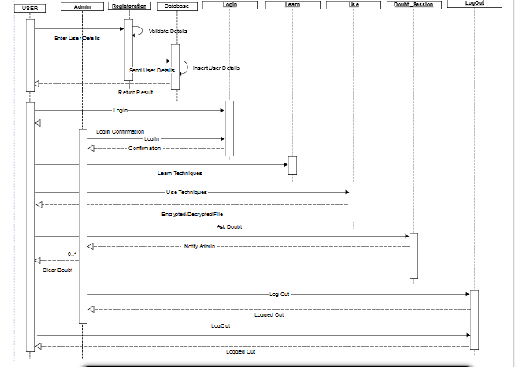

The User will first register on the website by entering his/her details. The details entered will be validated and if valid will be stored in the database. The database will send a reply to the user saying that the user has been registered. User will next log in to the website by entering the correct user name and password.
After logging in user will be taken to a page where he/she will be having a option to learn or use. By clicking on Learn option, user will be able to learn all the encryption techniques available at that time through an example. By choosing the Use option, user will be using a respective encrypting/decrypting technique to encrypt/decrypt a file or text.
Admin will also be logging in the website. There can be times that a user has a doubt. For that he/she can be using the doubt forum. The admin will be responsible for answering the query of the user.
Both the user and admin can log out after a session.

2.3 User interface issues

- Home Page
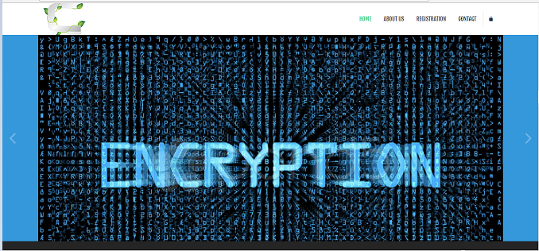

- Register
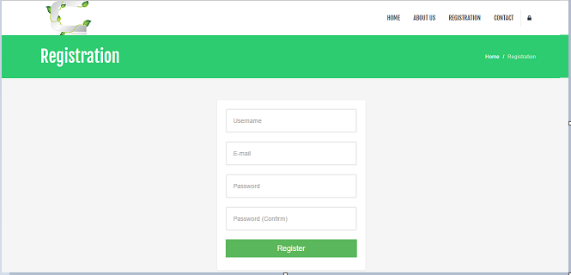

- Login
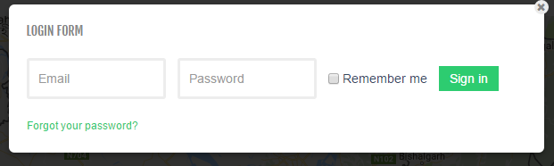

- Learn/Use
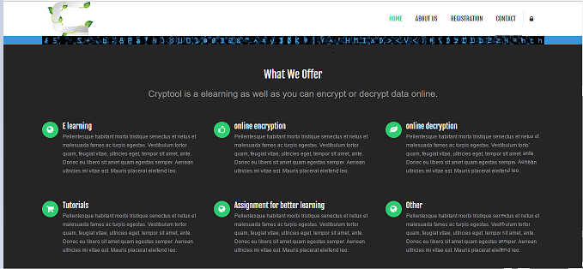

- Doubt Forum
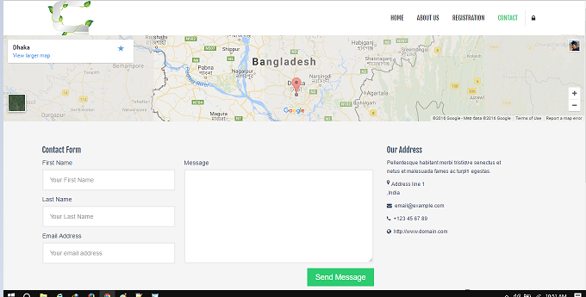

3. Detailed description of components
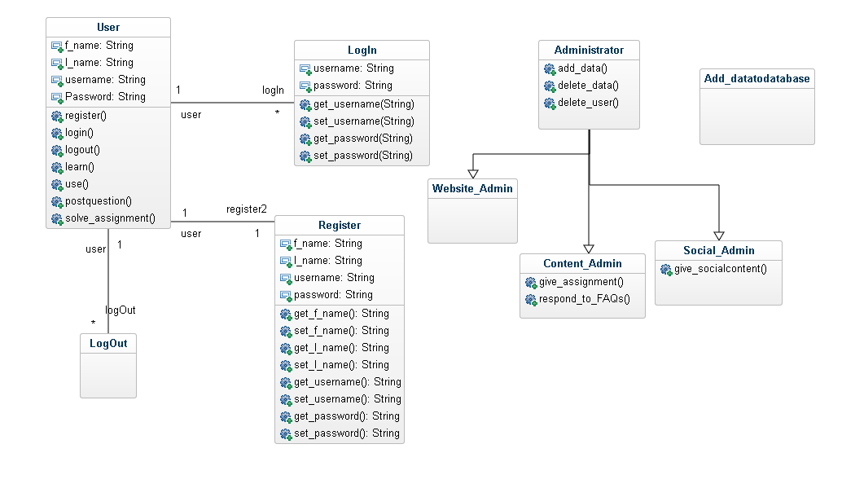
3.1 User
User will have to provide its first name, last name, username and password at the time of registration. And at the time of log in only username and correct password are required. The user can register, login and logout. After logging in the user can learn or use the tool. By clicking on learning, the user will have all the encryption/decryption techniques available to them for learning. They will be leaning through an example. By choosing the Use option, the User will provide a text or a file and choose one of the techniques. And he will be able to encrypt/decrypt accordingly. For clearing any query, the user can post question on the doubt forum. He can also practice the learned techniques by solving assignments.

3.2 Register
For registering, a new user will have to provide his/her username, password, first name and last name. The entered details will be stored in the database and will be looked upon for checking every time the user logs in.

3.3 Login
Admin or user will be providing the respective username and password for logging in the website. The username and password will be checked from the database and accordingly steps will be proceeded.

3.4 Logout
After a session is over the admin and user can log out after saving their progress.

3.5 Admin
Admin can add or delete data. For example, the admin can add new assignment or can add tests having questions based on various techniques. Admin can also delete data which is outdated or repeated. Also if a user is contaminating the learning environment, admin can delete the user.
One of the admin have to respond to the FAQs asked in the doubt forums and the other has to be socially active on social sites. This is to promote the website and to keep the user happy.

4.0 Reuse and relationships to other products

Our goal from the beginning was to make use of any existing code to avoid wasting time duplicating other’s work. We also decided to use open source or freeware solutions wherever possible. As we are creating software for a defined application, it is possible to use open source technologies for the learning tool. We are extending a previous tool that was meant for teaching various techniques and using them. We are implementing a website for our tool and a login system and the main feature - the doubt forum. Also we have improved the UI/UX. This is also the reason why we are not using the same tool. To have a very good User Interface and a simple one so that the User Experience is very good. Along with HTML5 and CSS3 we are using jQuery and Bootstrap to make our sites responsive and user friendly. To write our code we used Notepad++. For the database we are using MySQL.

The encryption tool can be used as the first step towards cyber security. If both the sender and receiver know the key used for encrypting, safe data can be send.

5.0 Design decisions and tradeoffs
The first issue we faced was whether to use a WordPress template or make our own using HTML, CSS etc. We chose to make our own webpages. One of the reasons was not many of us knew how to use WordPress.

To judiciously divide the project between all team members was another design issue. We finally decided to make a 3 tier design, which is an application program organized into three major parts. This was to promote modularity within separate parts of the system. Modularity provides encapsulation for the important pieces of the system. Using encapsulation, we are able to change important parts of the system without changing the whole system.

A possible tradeoff when considering the listing of various encryption techniques was to use a carousel instead of a vertical navbar fixed to the left of the screen. The decision was to use a navbar. Carousel changes after a few seconds automatically. What if the user wants to remain at a particular method, then he would have to keep clicking the back button repeatedly. Also with the navbar the user can see all the method at one time. The display is good and the user can jump to a new method easily.

6.0 Pseudo code for components

The following are the code snippets for the pages associated with the project.

- Home Page
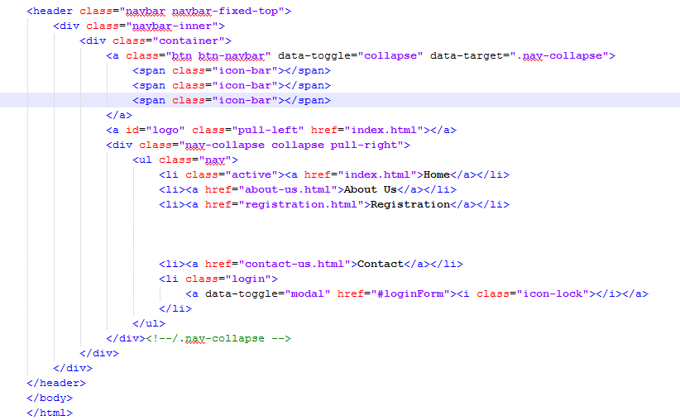

- Registration
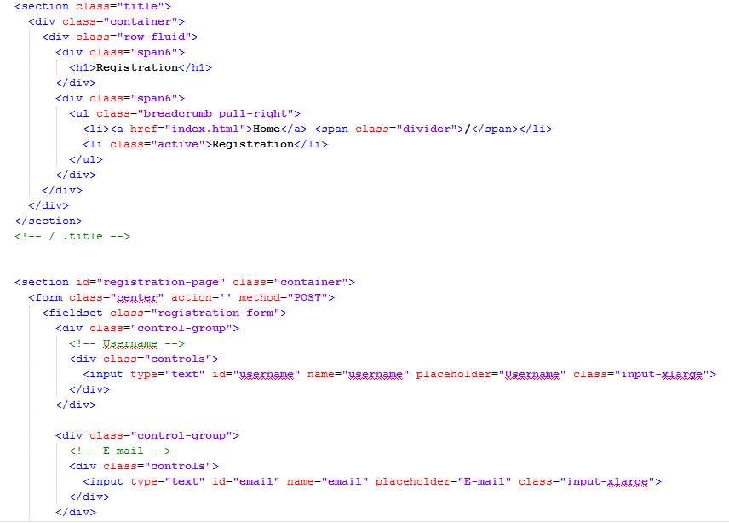
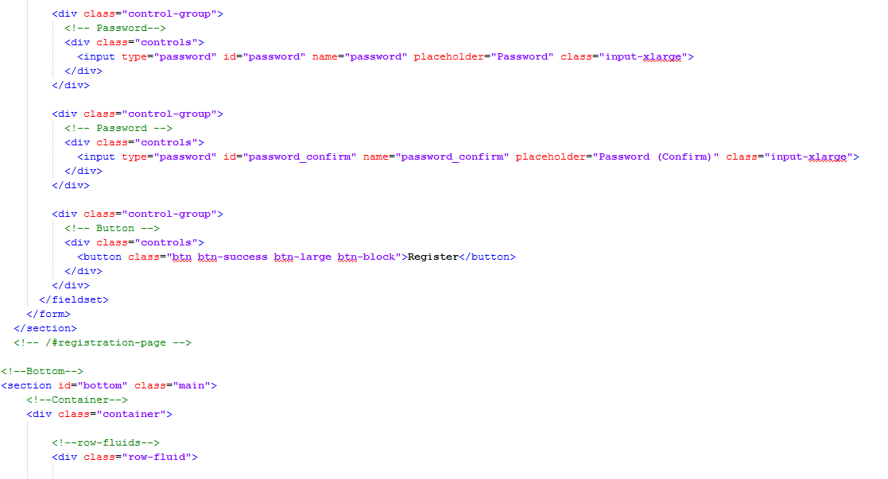

- Doubt Forum
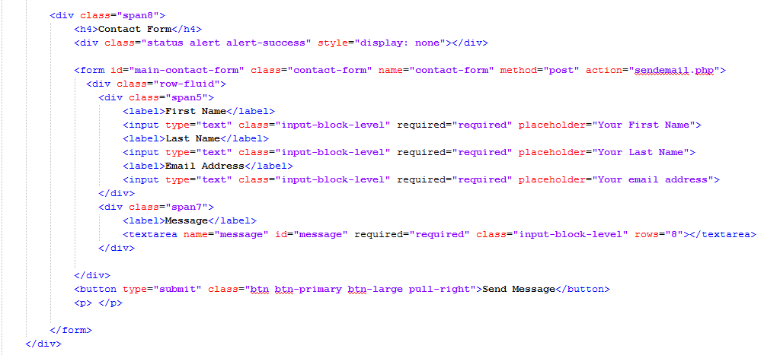
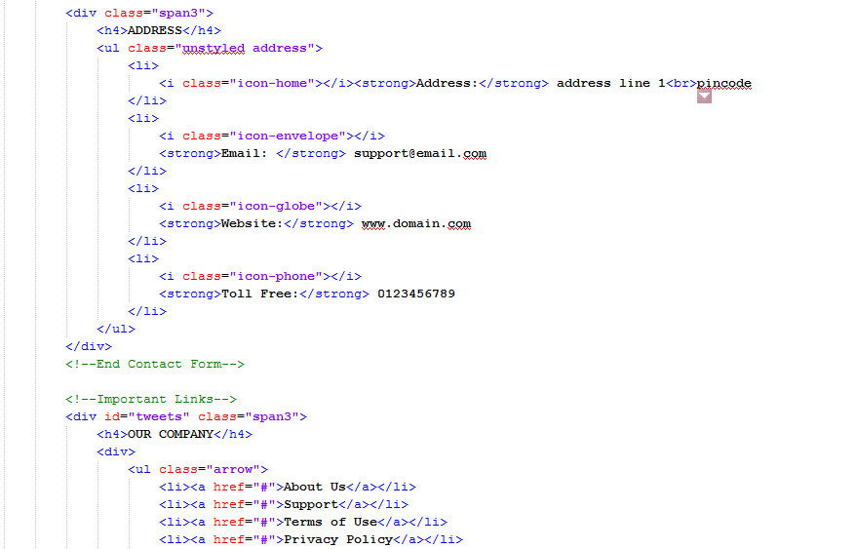

- Learn/Use
